

Darshan University

A Project Report on

**“Blood Bank Management System”**

Under the subject

**Software Engineering (2101CS503)**

B. Tech, Semester – V

Computer Science & Engineering Department

|  |  |
| --- | --- |
| Submitted By | |
| Student Name: Ritesh Lakhani | Enrollment No.: 22010101099 |
| Academic Year  (2024-2025) | |
| Internal Guide  Prof. Rajkumar Gondaliya  Darshan University | Dean-DIET  Dr. Gopi Sanghani  Darshan University |

|  |  |
| --- | --- |
|  | **Computer Science & Engineering Department**  **Darshan University** |

**DECLARATION**

We hereby declare that the SRS, submitted along with the **Software Engineering** **(2101CS503)** for entitled **“Blood Bank Management System”** submitted in partial fulfilment for the Semester-5 of **Bachelor Technology (B. Tech)** in **Computer Science and Engineering (CSE)** Departmentto Darshan University, Rajkot, is a record of the work carried out at **Darshan University, Rajkot** under the supervision of Prof. Rajkumar Gondaliyaand that no part of any of report has been directly copied from any students’ reports, without providing due reference.

Ritesh Lakhani

Student’s Signature

Date: __________

|  |  |
| --- | --- |
|  | **Computer Science & Engineering Department**  **Darshan University** |

**CERTIFICATE**

This is to certify that the SRS on **“Blood Bank Management System” has** been satisfactorily prepared by **Ritesh Lakhani** (**22010101099**) under my guidance in the fulfillment of the course **Software Engineering (2101CS503)** work during the academic year 2023-2024.

|  |  |  |
| --- | --- | --- |
| Internal Guide  Prof. Rajkumar Gondaliya  Darshan University |  | Dean-DIET  Dr. Gopi Sanghani  Darshan University |

**Acknowledgement**

I wish to express my sincere gratitude to my project guide Prof. **Rajkumar Gondaliya** and all the faculty members for helping me through my project by giving me the necessary suggestions and advices along with their valuable co- ordination in completing this work.

I also thank my parents, friends and all the members of the family for their precious support and encouragement which they had provided in completion of my work. In addition to that, I would also like to mention the Darshan University personals who gave me the permission to use and experience the valuable resources required for the project from the University premises.

Thus, in conclusion to the above said, I once again thank the faculties and members of **Darshan University** for their valuable support in completion of the project.

Thanking You

**Ritesh Lakhani**

**ABSTRACT**

The Blood Bank Management System is a Software designed to improve how blood bank work. It includes functionalities for donor, recipients, managers, administrators, quality testing, inventory control, and supply logistics.

The system helps donors to register easily and keeps track of their information. It also manages requests from hospitals and clinics for blood. Managers use it to oversee everything and make sure the system runs smoothly. Administrators control who can use the system and keep data safe.

Quality testing checks that blood is safe. Inventory control tracks how much blood is available and when it expires. Supply logistics handle getting blood where it’s needed, quickly and efficiently.

The Blood Bank Management System makes blood bank more efficient and helps ensure that blood donations are used effectively to help patients.

**Table of Contents**

List of Figures I

List of Tables II

1. Introduction 1
   1. Product perspective 1
   2. Product features 1

There are nine different users who will be using this product: 1

* + 1. Donor 1
    2. Recipients 1
    3. Manager 1
    4. Administrator 1
    5. Quality Tester 1
    6. Inventory Controller 1
    7. Supply Coordinator 1
    8. Laboratory Technician……………………………………………………………………………………….…………..1
    9. Campaign Coordinator…………………………………………………………………………………………………..1
  1. Functional Requirement………………………………………………………………………………………………………..2
     1. Donor…………………………………………………………………………………………………………………………….2
     2. Recipients .2
     3. Manager .2
     4. Administrator ..2
     5. Quality Testing……………………………………………………………………………………………………………….3
     6. Inventory Control…………………………………………………………………………………………………………..3
     7. Supply Logistics………………………………………………………………………………………………………………3
  2. Non-Functional Requirement 3
     1. Usability 3
     2. Security 3
     3. Reliability 3
     4. Performance 3

1. Design and Implementation Constraints 4
   1. Use case diagram 4
   2. Activity diagram and Swimlane diagram 5
   3. Sequence diagram………………………………………..……………………………………………………………………….9
   4. State diagram………………………………………………………………………………………………………………………10
   5. Class diagram………………………………………………………………………………………………………………………11
   6. Data flow diagram……………………………………………………………………………………………………………….12
      1. Context diagram (Level 0)…………………………………………………………………………………………….12
      2. DFD Level-1………………………………………………………………………………………………………………...12
2. External interface requirement (Screens) 13
   1. Screen-1: Registration Form 13
   2. Screen-2: Blood Donation Campaign Management 14
   3. Screen-3: Health Information. 15
   4. Screen-4: Transaction Information…………………………………..……………………….…………………………16
   5. Screen-5: Donation Details…………………………………………………………….……….…………………………..17
3. Database design 18
   1. List of Tables 18
4. Stories and Scenario 20
   1. Story-1: Donor Administration ……………………………………………………………………………………………20
      1. Scenario# S1.1 20
      2. Scenario# S1.2 20
   2. Blood Quality Testing 21
      1. Scenario# S2.1 21
   3. Supply Chain Coordination 21
      1. Scenario# S3.1 21
5. Test cases 22
   1. Test Suit-1: 22

7 Reference………………………………………………………………………………………………………………………………………26

# List of Figures

Figure 2.1-1 Use case diagram for Blood Bank Management System……………………………………………………4

Figure 2.2-1 Activity diagram for Blood donation ………………………………………………………………………………..5

Figure 2.2-2 Activity diagram for Blood Recipients ………………………………………………………………………………6

Figure 2.2-1 Swimlane diagram for Donor …………………………………………………………………………………………..7

Figure 2.2-2 Swimlane diagram for Recipients……………………………………………………………………………………..8

Figure 2.3-1 Sequence diagram for blood donation ………………………..…………………………………………………..9

Figure 2.4-1 State diagram of blood ……………………………………………….…………………………………………………..10

Figure 2.5-1 Class diagram for Blood bank management system ….…………………………………………………….11

Figure 2.6-1 Context diagram for Blood bank management system ……………………………………………………12

Figure 2.6-2 DFD level-1 for Blood Bank management system ……………………………………………………………12

Figure 3.1-1 Screen-1: Registration Form……………………………….……………………………………………………………13

Figure 3.2-1 Screen-2: Blood Donation Campaign Management …………………………………………………………14

Figure 3.3-1 Screen-3: Health Information…………………………………………………………………………………………..15

Figure 3.4-1 Screen-4: Transaction Information………………………………..…………………………………………………16

Figure 3.5-1 Screen-5: Donation Details……………………………………………………………………………………………….17

# List of Tables

Table 3.1-1 Screen element of Registration form 13

Table 3.1-1 Screen element of Blood Donation Campaign Management 14

Table 3.1-1 Screen element of Health Information 15

Table 3.1-1 Screen element of Transaction Information 16

Table 3.1-1Screen element of Donation Details 17

Table 4.1-1 Table: Recipients 18

Table 4.1-2 Table: Donors 18

Table 4.1-3 Table: Lab Technicians 18

Table 4.1-4 Table: Inventory Controller 18

Table 4.1-5 Table: Supply Coordinator 19

# Introduction

## Product perspective

The Blood Bank Management System is a software solution designed to improve blood bank operations with key functionalities. It manages donor registrations and tracks donations, ensuring accurate donor information. Blood Bank Management System handles blood requests healthcare facilities, ensuring timely distribution to recipients. It provides oversight to optimize inventory and quality control, and ensures secure access and data integrity. Through comprehensive testing, it verifies blood safety and tracks inventory for efficient supply logistics. Overall, Blood Bank Management System enhances transparency, resource management, and the effectiveness of blood transfusion services.

## Product features

### There are nine different users who will be using this product:

### Donor

* Responsible for registering and donating blood.
* Can view personal donation history and update contact information.

### Recipient

* Submit requests for blood units from healthcare facilities.
* Views status updates on requested blood units and their availability.

### Manager

* Oversees and monitors all aspects of blood bank operations.
* Generates reports on donor trends, inventory levels, and operational metrics.

### Administrator

* Responsible for overall system administration and configuration.
* Manages user accounts, assign roles, and ensures data security.

### Quality Tester

* Conducts through testing of blood units for safety and quality.
* Records and maintains testing results and compliance records.

### Inventory Controller

* Tracks real-time inventory levels of blood units.
* Manages stock levels, minimizes wastage, and ensures optimal storage conditions.

### Supply Coordinator

* Coordinator the distribution of blood units to healthcare facilities.
* Manages logistics for timely response to supply requests and emergencies.

### Laboratory Technician

* Conducts quality testing on donated blood samples, records test results, and updates the testing status of blood units.

### Campaign Coordinator

* Organizes and manages blood collection campaigns.
* They schedule campaigns, track registrations, communicate with donors, and manage campaign logistics such as assigning staff, managing equipment and supplies, and monitoring campaign progress.

## Functional Requirement

### Donor

* User Registration: Donors can create an account by providing personal information and medical history.
* User Login: Donors can create an account by providing personal information and medical history.
* Update Profile: Donors can update their personal information and medical history.
* View Donation History: Donors can update their personal information and medical history.
* Schedule Donation: Donors can schedule appointments for donating blood.
* Cancel Donation Appointment: Donors can cancel scheduled donation appointments.
* View Eligibility: Donors can check their eligibility to donate based on predefined criteria.
* Receive Notifications: Donors receive notifications for upcoming appointments and reminders for future donations.
* Blood Group Entry: Donors can enter their blood group information.
* Contact Support: Donors can contact support for any assistance or queries.

### Recipients

### User Registration: Recipients can create an account by providing personal and medical information.

* User Login: Recipients can log in to their accounts using secure credentials.
* Update Profile: Recipients can update their personal information and medical history.
* Request Blood: Recipients can submit requests for specific blood types.
* View Request Status: Recipients can check the status of their blood requests.
* View Donation History: Recipients can view the history of blood received.
* Schedule Pickup: Recipients can schedule a pickup time for the requested blood.
* Cancel Request: Recipients can cancel a blood request if it is no longer needed.
* View Blood Availability: Recipients can view the availability of different blood types in the inventory.
* Receive Notifications: Recipients receive notifications regarding their requests and availability of blood.

### Manager

* Manager Login: Managers can log in to their accounts using secure credentials.
* Add New Blood Stock: Managers can add new blood units to the inventory.
* Update Blood Stock: Managers can update the details of existing blood units.
* Delete Blood Stock: Managers can remove outdated or unused blood units from the inventory.
* View Blood Inventory: Managers can view the current inventory of blood units.
* Generate Inventory Report: Managers can generate detailed reports on blood inventory levels.
* Monitor Requests: Managers can monitor blood requests and their statuses.
* Approve/Reject Requests: Managers can approve or reject blood requests based on availability and eligibility.
* Manage User Accounts: Managers can add, update, and delete user accounts for donors and recipients.
* View User Activity: Managers can view logs of user activities and interactions with the system.

### Administrator

* Admin Login: Admins can securely log in to access their account and the admin interface.
* System Oversight: Admins oversee the entire system, ensuring smooth and efficient operations.
* Access Control: Admins define and control user roles and permissions, ensuring appropriate access levels for different users.
* Security Settings: Admins configure and update security settings to protect sensitive data and ensure compliance with data privacy regulations.
* Activity Monitoring: Admins monitor system activities through audit logs, detecting and preventing unauthorized access or suspicious activities.
* System Customization: Admins customize system settings to align with the specific needs and workflows of the blood bank.
* Data Backup: Admins perform data backup and recovery operations to ensure critical data preservation and restoration in case of system failure.
* Report Generation: Admins generate comprehensive reports on donors, recipients, inventory, and transactions, providing valuable insights for decision-making.
* Notification Configuration: Admins configure and manage email and SMS notifications to keep stakeholders informed about important updates and reminders.
* Compliance Assurance: Admins ensure that the Blood Bank Management System complies with relevant healthcare regulations and standards, maintaining the system's integrity and trustworthiness.

### Quality Testing

* Blood Testing Records: Record the results of tests conducted on blood units for various parameters such as blood type, infections, and compatibility.
* Quality Assurance Reports: Generate detailed reports on the quality testing outcomes, including pass/fail rates, and flag any units that do not meet the required standards.
* Testing Schedule Report: Schedule and track periodic quality testing for stored blood units to ensure ongoing compliance with safety standards.

### Inventory Control

* Real-Time Inventory Tracking: Track the real-time status of blood units, including blood type, quantity, and expiration dates, to maintain accurate inventory levels.
* Inventory Alerts: Set up alerts for low inventory levels or approaching expiration dates to ensure timely replenishment or disposal of blood units.
* Inventory Audits: Perform regular inventory audits to verify stock levels and ensure data accuracy in the inventory system.

### Supply Logistics

* Supply chain Monitoring: Monitor the flow of blood units throughout the supply chain, from donation to distribution, ensuring efficient logistics management.
* Distribution Oversight: Manage the distribution of blood units to hospitals and clinics, tracking delivery schedules and ensuring timely supply.
* Resource Allocation: Allocate resources effectively to manage the supply of blood units, optimizing distribution routes and minimizing wastage.
* **Demand Prediction:** Uses data to forecast future blood supply needs, optimizing logistics and reducing shortages.

## Non-Functional Requirement

### Usability:

* The system should have an intuitive and user-friendly interface to facilitate ease of use for all user roles.

### Security

* Keep donor and recipient information secure and confidential, allowing access only to authorized personnel.

### Reliability

* The system should be reliable, with minimal downtime and the ability to recover data in case of system failures or crashes.

### Performance

* The system should be capable of handling a large volume of donor registrations, test results, inventory records, and supply requests without significant performance degradation.

# Design and Implementation Constraints

## Use case diagram

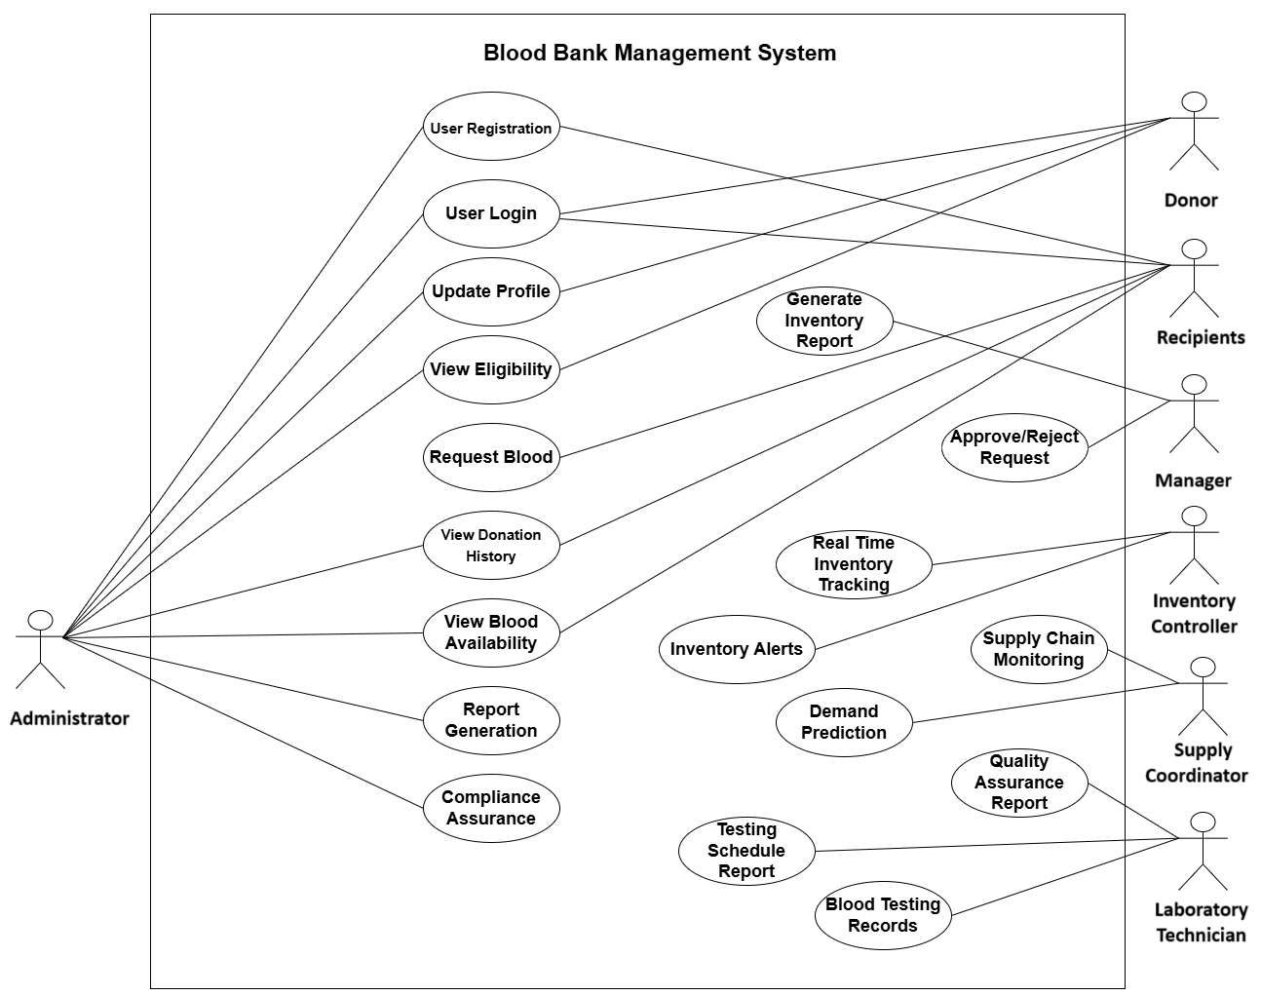

Figure ‑ Use case diagram for blood bank Management system

## Activity diagram and Swimlane diagram

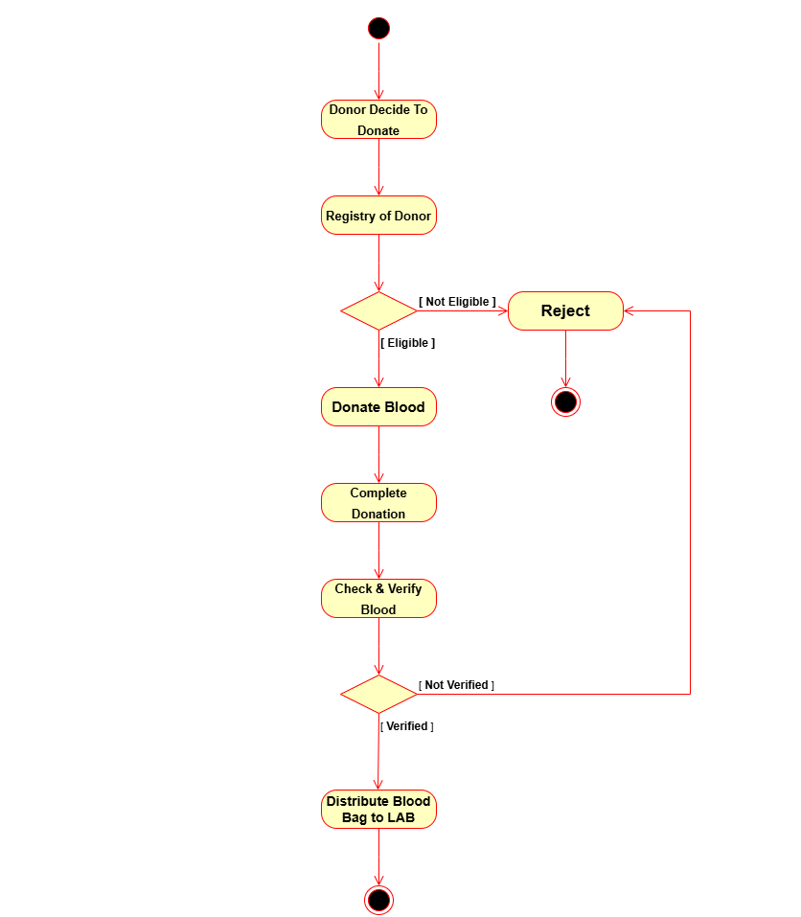

Figure ‑ Activity diagram for Blood Donation

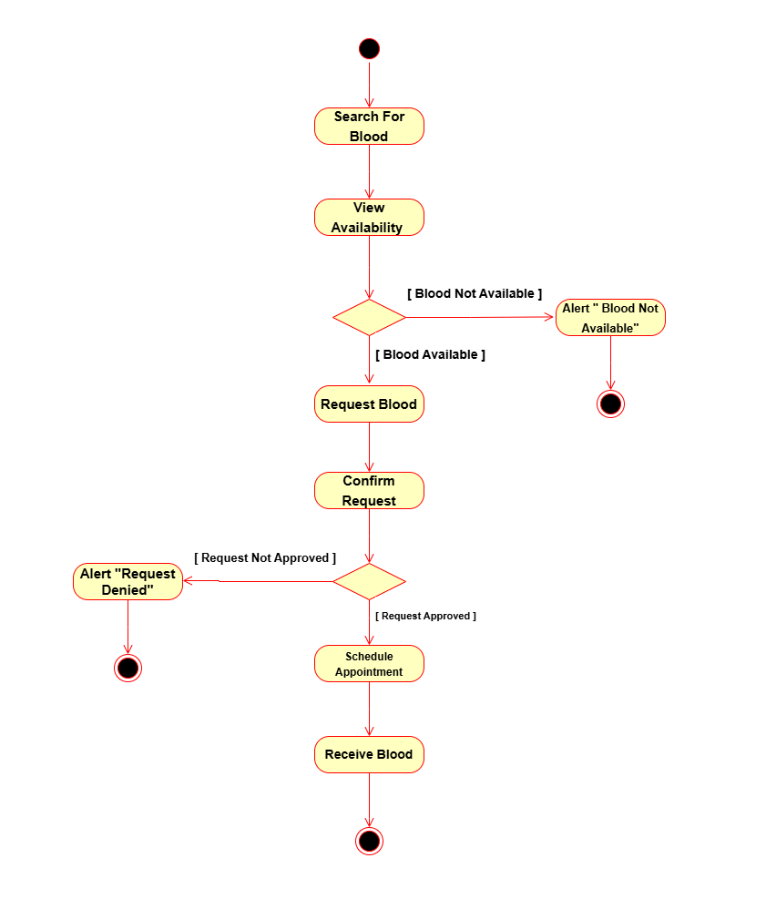

Figure 2.2‑1 Activity diagram for Blood Recipients

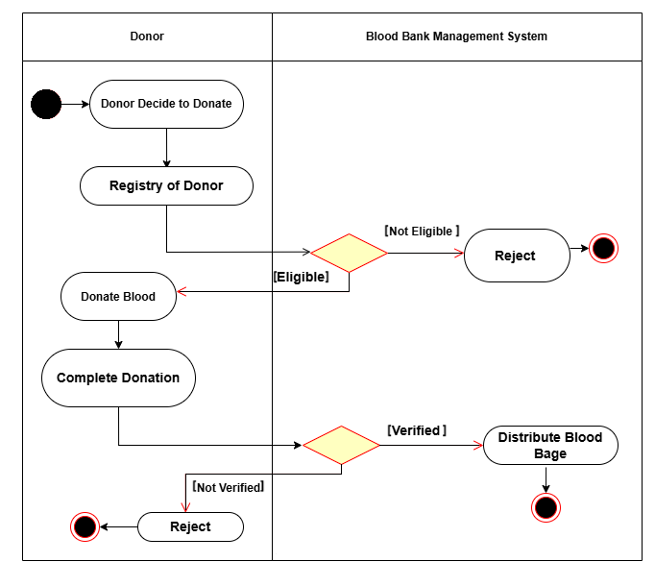

Figure ‑ Swimlane diagram for Donor

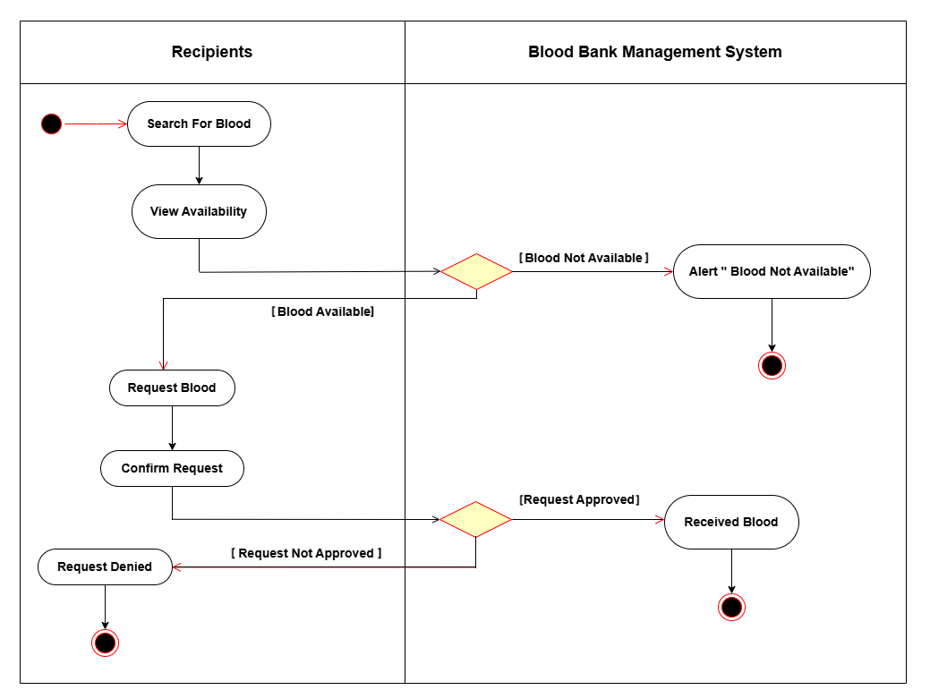

Figure 2.2‑3 Swimlane diagram for Recipient

## Sequence diagram

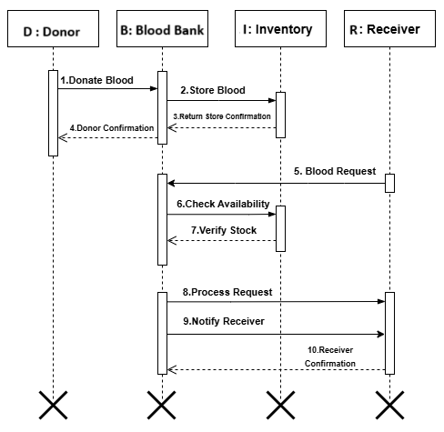

Figure ‑ Sequence diagram for Blood Bank Management

## State diagram

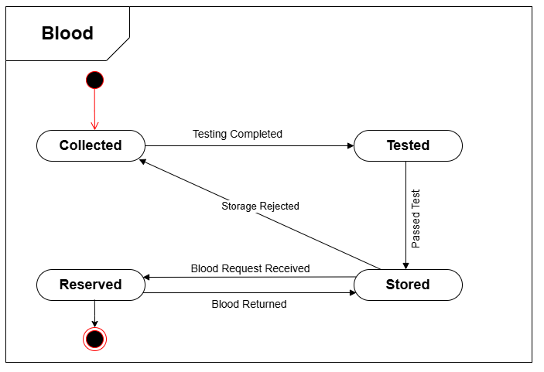

Figure 2.4‑1 State diagram of Blood

## Class diagram

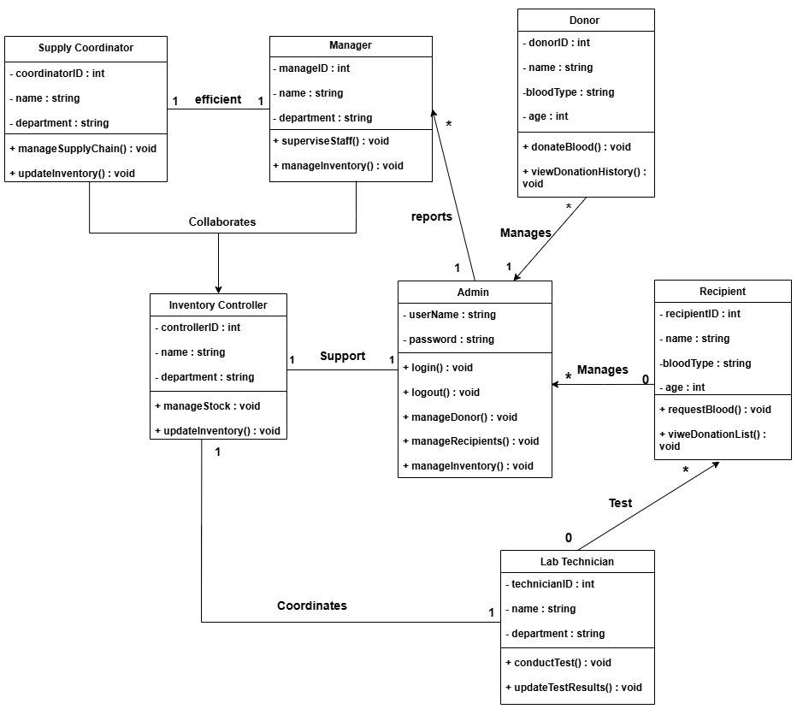

Figure ‑ Class diagram for Blood Bank Management System

## Data flow diagram

### Context diagram (level-0)

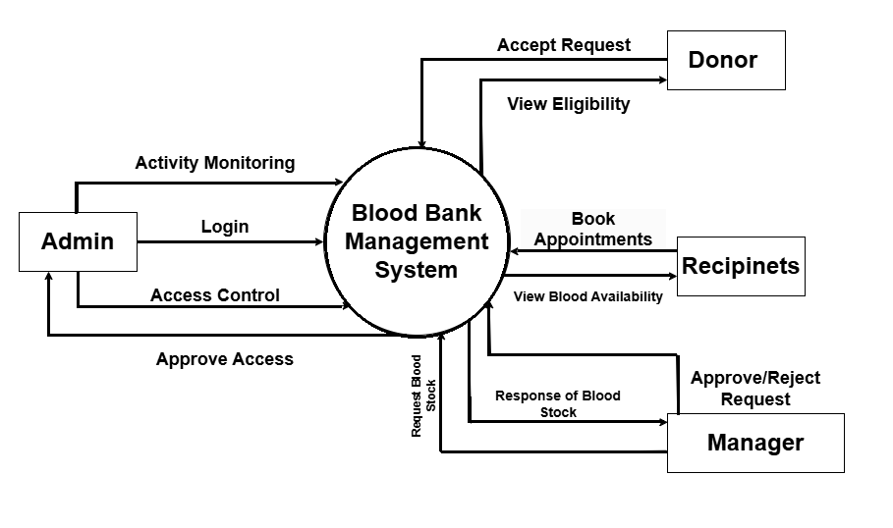

Figure ‑ Context diagram for Blood Bank Management System

### DFD Level-1

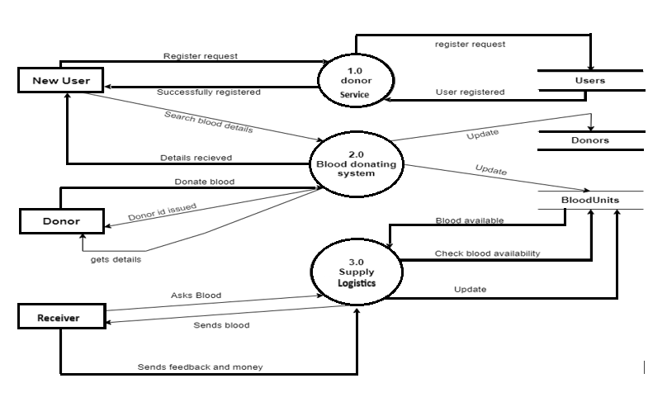

Figure ‑ DFD level-1 for Blood Bank Management system

# External interface requirement (Screens)

## Screen-1: Registration Form

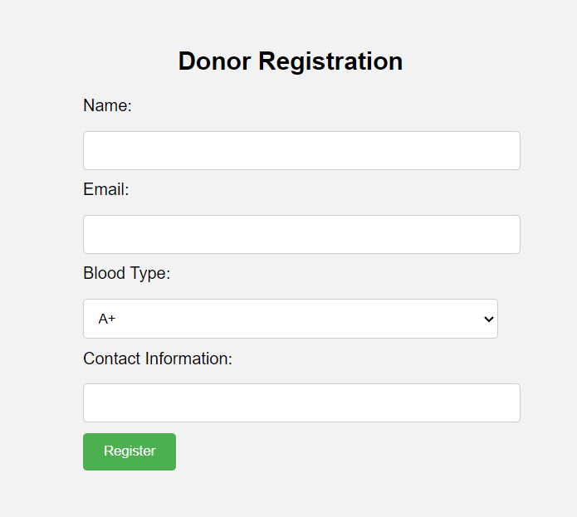

Figure ‑ Screen-1: Registration Form

**Purpose:** This form will allow the target end-users to register in the system. To register, the following information will be encoded in the system.

Table ‑ Screen element of Registration form

|  |  |  |  |  |  |
| --- | --- | --- | --- | --- | --- |
| **Sr.** | **Screen Element** | **Input Type** | **O/M** | **1/N** | **Description** |
| **1** | Name | Textbox | M | 1 | Name field should be editable and accept the  Name. |
| **2** | Email | Textbox | M | 1 | Email field should be editable and accept the  email with proper format. |
| **3** | Blood Type | Dropdown | M | 1 | Dropdown for selecting blood types |
| **4** | Contact  information | Textbox | M | 1 | Field for user’s contact information |
| **5** | Register | Button | ------ | ------ | Register is a button for store the entered data  into database. |

## Screen-2: Blood Donation Campaign Management

## 

Figure ‑ Screen-2: Blood Donation Campaign management screen

**Purpose:** This module will allow to organize and manage blood donation campaign.

Table 3.2‑1 Screen element of Blood Donation Campaign Management

|  |  |  |  |  |  |
| --- | --- | --- | --- | --- | --- |
| Sr. | Screen Element | Input Type | O/M | 1/N | Description |
| 1 | Username | Textbox | M | 1 | Username field should be editable and accept the Username. |
| 2 | Password | Password | M | 1 | Password field should be editable and accept the password and display as star or dot. |
| 3 | Remember Me | Checkbox | M | 1 | Saving login credentials through remember me checkbox |
| 4 | I forgot my password | Link | ------ | ------ | Link for navigate to Forgot password page for allows users to recover password. |
| 5 | Register a new membership | Link | ------ | ------ | Link for navigate to membership registration. |
| 6 | Sign in | Button | ------ | ------ | Login button navigates to another page even if valid login credentials. |

## Screen-3: Health Information

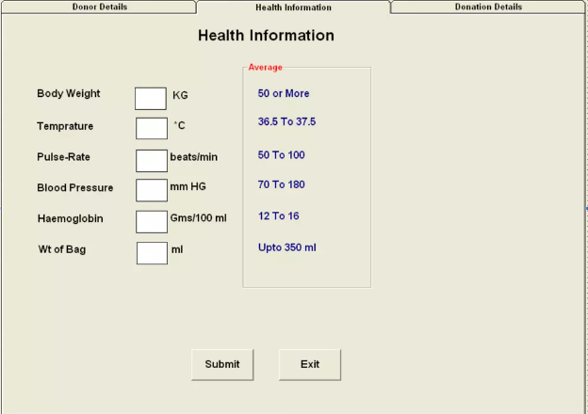

Figure ‑ Screen-3: Health Information

**Purpose:** This module check the donor health information according to some condition.

Table 3.3‑1 Screen element of Health Information

|  |  |  |  |  |  |
| --- | --- | --- | --- | --- | --- |
| Sr. | Screen Element | Input Type | O/M | 1/N | Description |
| 1 | Body Weight | Textbox | M | 1 | Weight of the donor in kilograms (kg). |
| 2 | Temperature | Textbox | M | 1 | Body temperature of the donor in degrees Celsius (°C). |
| 3 | Pulse-Rate | Textbox | M | 1 | Pulse rate of the donor in beats per minute (beats/min). |
| 4 | Blood Pressure | Textbox | M | 1 | Blood pressure of the donor in millimetres of mercury (mm HG). |
| 5 | Haemoglobin | Textbox | M | 1 | Haemoglobin level of the donor in grams per 100 millilitres (Gms/100 ml). |
| 6 | Wt. of Bag | Textbox | M | 1 | Weight of the blood bag in millilitres (ml). |
| 7 | Submit | Button | M | 1 | Submit is a button for store the entered data into database. |
| 8 | Exist | Button | O | 1 | Exits the Health Information form without saving. |

## Screen-4: Transaction Information

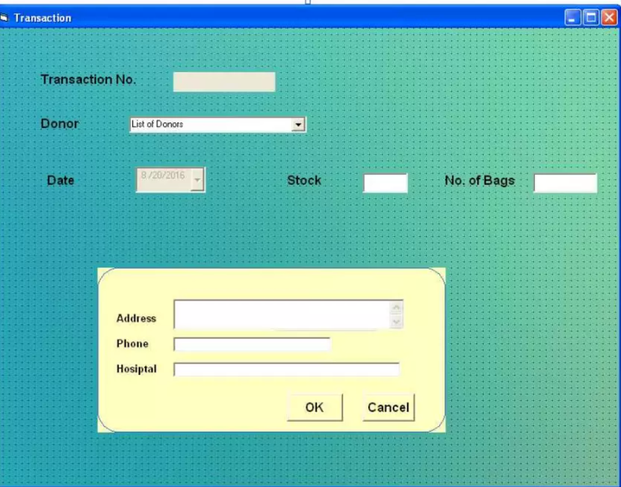

Figure 3.4‑1 Screen-4: Transaction Information

**Purpose:** The transaction screen records and manages blood donation details, ensuring accurate tracking, inventory management, and data integrity.

Table 3.4‑1 Screen element of Transaction Information

|  |  |  |  |  |  |
| --- | --- | --- | --- | --- | --- |
| Sr. | Screen Element | Input Type | O/M | 1/N | Description |
| 1 | Transaction No | Textbox | M | 1 | Unique identifier for the transaction. |
| 2 | Donor | Dropdown | M | 1 | Select a donor from the list of registered donors. |
| 3 | Date | Date Picker | M | 1 | Date of the transaction. |
| 4 | Stock | Textbox | M | 1 | Current stock of blood units available. |
| 5 | No. of Bags | Textbox | M | 1 | Number of blood bags involved in the transaction. |
| 6 | Address | Textbox | M | 1 | Address associated with the transaction. |
| 7 | Phone | Textbox | M | 1 | Phone number associated with the transaction. |
| 8 | Hospital | Textbox | M | 1 | Name of the hospital associated with the transaction. |
| 9 | Ok | Button | M | 1 | Confirms and saves the transaction information. |
| 10 | Cancel | Button | O | 1 | Cancels the transaction and exits without saving. |

## Screen-5: Donation Details

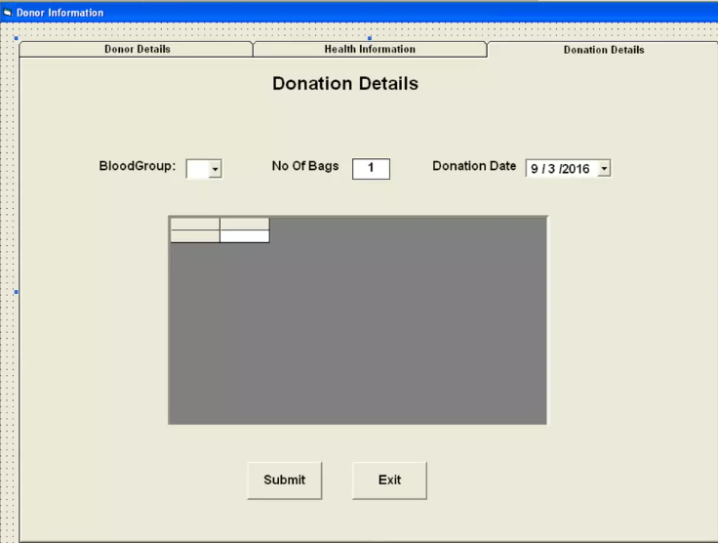

Figure 3.5-1 Screen-5: Donation Details

**Purpose:** The donation details screen captures and manages the specifics of each blood donation event, ensuring accurate recording of the blood group, number of bags donated, and the donation date.

Table 3.5‑1 Screen element of Donation Details

|  |  |  |  |  |  |
| --- | --- | --- | --- | --- | --- |
| Sr. | Screen Element | Input Type | O/M | 1/N | Description |
| 1 | Blood Group | Dropdown | M | 1 | Select the Blood Group of the Donor |
| 2 | No of Bags | Text | M | 1 | Number of blood bags donated. |
| 3 | Donation Date | Date Picker | M | 1 | Date of the blood donation. |
| 4 | Submit | Button | M | 1 | Submits the donation details form. |
| 5 | Exist | Button | O | 1 | Number of blood bags involved in the transaction. |

# Database design

## List of Tables

* Recipients
* Donors
* Lab Technicians
* Inventory Controller
* Supply Coordinator

Table 4.1‑1 Table: Recipients

|  |  |  |  |  |
| --- | --- | --- | --- | --- |
| Column | Data Type | Null | Keys & Constrains | Default Value & Description |
| RecipientsID | int | NN | PK (Auto Increment) |  |
| Recipientname | varchar(100) | NN |  |  |
| Password | varchar(100) | AN |  |  |
| Status | Varchar(100) | AN |  |  |
| Age | int | AN |  |  |

Table 4.1‑2 Table: Donors

|  |  |  |  |  |
| --- | --- | --- | --- | --- |
| Column | Data Type | Null | Keys & Constrains | Default Value & Description |
| DonorID | int | NN | PK (Auto Increment) |  |
| RecipientsID | int | NN | FK | Reference of Recipients Table |
| Name | varchar(100) | NN |  |  |
| BloodType | varchar(100) | NN |  |  |
| ContactInfo | Varchar(100) | NN |  |  |

Table 4.1‑3 Table: Lab Technicians

|  |  |  |  |  |
| --- | --- | --- | --- | --- |
| Column | Data Type | Null | Keys & Constrains | Default Value & Description |
| LabTechID | int | NN | PK (Auto Increment) |  |
| RecipientsID | int | NN | FK | Reference of Recipients Table |
| Name | Varchar(100) | NN |  |  |
| PhoneNo | Varchar(100) | AN |  |  |
| Specialization | Varchar(100) | NN |  |  |

Table ‑ Table: Inventory Controller

|  |  |  |  |  |
| --- | --- | --- | --- | --- |
| **Column** | **Data Type** | **Null** | **Keys & constrains** | **Default Value & Description** |
| **InventoryMgrID** | int | NN | PK (Auto Increment) |  |
| **RecipientsID** | int | NN | FK | Reference of Recipients Table |
| **Name** | varchar (100) | NN |  |  |
| **Email** | Varchar(100) | AN |  |  |
| **ShiftTiming** | Varchar(100) | AN |  |  |

Table ‑ Table: Supply Coordinator

|  |  |  |  |  |
| --- | --- | --- | --- | --- |
| **Column** | **Data Type** | **Null** | **Keys & constrains** | **Default Value & Description** |
| **SupplyMgrID** | int | NN | PK (Auto Increment) |  |
| **RecipientsID** | int | NN | FK | Reference of Recipients Table |
| **Name** | varchar (100) | NN |  |  |
| **PhoneNo** | Varchar(100) | NN |  |  |
| **Email** | Varchar(100) | AN |  |  |
| **LogisticsArea** | Varchar(100) | NN |  |  |

# Stories and Scenario

## Story-1: Donor Administration

|  |  |  |
| --- | --- | --- |
| *Story # S1* | : | As a Donor,  I want to add and edit information about me.  So that I can donate blood. |
| Priority | **:** | High |
| Estimate | **:** | L |
| Reason | **:** | Here donor information is very important as to donate blood donor has to add his/her information in the application. |

### Scenario# S1.1

|  |  |  |
| --- | --- | --- |
| *Scenario# S1.1* | : | Donor information update. |
| Prerequisite | **:** | Should be on profile page for donor. |
| Acceptance Criteria | **:** | **Given:**  The user is logged in as donor.  **When:** They update their personal information, and they save changes.  **Then** their information should be updated in the system. |

### Scenario# S1.2

|  |  |  |
| --- | --- | --- |
| *Scenario# S1.2* | : | Check donor eligibility. |
| Prerequisite | **:** | Should be on profile Page for donor. |
| Acceptance Criteria | **:** | **Given:** The user is logged in as a donor.  **When:** They provide their medical history.  **Then** they should receive information about their eligibility to donate  blood. |

## Story-2: Blood Quality Testing

|  |  |  |
| --- | --- | --- |
| *Story # S2* | : | As a laboratory technician,  I should be able to perform Quality testing on a blood unit , and  Should be able to associate test results with the blood unit in the system. |
| Priority | **:** | High |
| Estimate | **:** | M |
| Reason | **:** | So that the user can know that the blood they donated can be used for  Someone or not. |

### Scenario# S2.1

|  |  |  |
| --- | --- | --- |
| *Scenario#* ***S2.1*** | **:** | Record Blood Test Results. |
|  |  |  |
| **Prerequisite** | **:** | The user should be logged in as laboratory technician and should be on  Record test results page. |
| **Acceptance**  **Criteria** | **:** | **Given** the user is a laboratory technician.  **When** they perform quality tests on a blood unit and record the test results**. Then** they should be able to associate (upload) it with the blood unit in the system. |

## Story-3: Supply Chain Coordination

|  |  |  |
| --- | --- | --- |
| *Story # S3* | : | As a supply manager,  I should be able to accept the supply request from an organization,  and should be able to allocate required blood units for that request and fulfil  it. |
| Priority | **:** | High |
| Estimate | **:** | L |
| Reason | **:** | So that the system is updated about the request fulfilled and remaining. |

### Scenario# S3.1

|  |  |  |
| --- | --- | --- |
| *Scenario#* ***S3.1*** | **:** | Handle Supply Request. |
| **Prerequisite** | **:** | Supply manager should be on the requests page. |
| **Acceptance**  **Criteria** | **:** | **Given** the user is a supply manager.  **When** they receive a supply request from a recipient organization and they allocate the requested blood units,  **Then** the request should be marked as fulfilled. |

# Test cases

## Test Suit-1:

|  |  |  |  |
| --- | --- | --- | --- |
| **Project Name:** | **Blood Bank Management System** | **Test Designed by:** | **Ritesh Lakhani** |
| **Module Name:** | **Emergency Coordinator Dashboard** | **Test Designed date:** | 22-08-2024 |
| **Release Version:** | **1.0** | **Test Executed by:** | **Yet to be tested** |
|  |  | **Test Execution date:** |

|  |  |  |  |  |  |  |
| --- | --- | --- | --- | --- | --- | --- |
| **Pre-condition**: **Web application should be accessible and should be logged in as Emergency Coordinator.** | | | | | | |
| Test Case ID | **Test Title** | **Test Type** | **Description** | | | **Test Case ID** |
| **TC_001** | Verify the stock of blood for  Emergency supply. | Functional | Manage the blood emergency. | stock | for | TC_001 |
| **TC_002** | Add or remove blood units from inventory to emergency  Supply. | Functional | Manage blood emergency supply. | units | in | TC_002 |
| **TC_003** | Verify priority alerts when there  Is an emergency to supply blood. | Functional | Verify the priority alerts that must be supplied immediately. | | | TC_003 |
| **TC_004** | Review and Approve Pending Emergency Blood Supply Requests. | Functional | Ensure the emergency coordinator can review and approve pending blood supply requests on the dashboard. | | | TC_004 |

|  |  |
| --- | --- |
| **Test Case Title** | Verify the stock of blood for emergency supply |
| **Test Type** | Functional |
| **Test Priority** | High |
| **Pre-condition** | Web application should be accessible and should be logged in with Emergency  Coordinator credentials. |

|  |  |  |  |  |  |  |  |
| --- | --- | --- | --- | --- | --- | --- | --- |
| **Test Step** | **Test Case Description** | **Expected Result** | **Actual Result** | **Status** | **Comment** | **Data** | **BUG ID** |
| 1 | Go to the stock page of  emergency supply. | You are  successfully redirected to  emergency stock page. | Successfully redirected to emergency Stock Page | Pass |  |  |  |

|  |  |  |  |  |  |  |  |
| --- | --- | --- | --- | --- | --- | --- | --- |
| 2 | Update the stock. (You will have to update it from another page.) | The changes are reflected on the list. | Changes accepted | Pass |  |  |  |
| 3 | Check the date and time of stock last updated. | The date and time of the last stock updated should be accurate. | Date and Time should be accurate | pass |  | Date and  time of  stock last updated. |  |

|  |  |
| --- | --- |
| **Test Case Title** | Add or remove blood units from inventory to emergency supply. |
| **Test Type** | Functional |
| **Test Priority** | High |
| **Pre-condition** | Web application should be accessible and should be logged in with Emergency  Coordinator credentials. |

|  |  |  |  |  |  |  |  |
| --- | --- | --- | --- | --- | --- | --- | --- |
| Test Step | Test Description | Expected Result | Actual Result | Status | Comment | Data | Bug ID |
| 1 | Go to the update emergency blood supply inventory page. | You are successfully redirected to the update emergency blood supply inventory page. |  | Pass |  |  |  |
| 2 | Add a blood unit in the emergency supply that is available in inventory. | The blood unit is added successfully. | The blood unit is added and the inventory count update immediately. | Pass |  |  |  |
| 3 | Remove a blood unit from emergency supply and add it to inventory which is not expired. | The blood unit is removed successfully. | The blood unit is removed and correctly added to the inventory. | Pass |  |  |  |
| 4 | Remove an expired blood unit from emergency supply. | The blood unit is removed successfully and added to the discard list. | The blood unit is removed, and added to the discard list. | Pass |  |  |  |
| 5 | Send notification to all users as soon as the blood they request is supplied. | Notification is sent successfully. | Notifications were sent and all users reported receiving them. | Pass | login with username: Riteshlakhani15 and  password: Ritesh12345 and request a blood available in emergency in supply |  |  |

|  |  |
| --- | --- |
| **Test Case Title** | Verify priority alerts when there is an emergency to supply blood. |
| **Test Type** | Functional |
| **Test Priority** | High |
| **Pre-condition** | Web application should be accessible and should be logged in with  emergency coordinator credentials. |

|  |  |  |  |  |  |  |  |  |
| --- | --- | --- | --- | --- | --- | --- | --- | --- |
| **Test Step** | **Test Case Description** | **Expected Result** | **Actual Result** | **Status** | **Comment** | **Data** | **Bug ID** | |
| 1 | Verify that you can see demo alerts in the alerts section. | You can see demo test alerts in alerts section. | Successfully see the all demo the alerts | pass |  | Demo alerts are provided by  developer in alerts section. |  | |
| 2 | Verify that you can receive emergency alerts for blood supply. | You can see the alerts for emergency blood supply. | Successfully see the all emergency the alerts | pass |  | login with username: kirtanmanek01 and password: kirtan12345 as user and  request in the emergency blood supply. |  | |
| 3 | Verify that the emergency information is  accessed by clicking on that alert. | You are  redirected to the information page of that emergency alert. | Successfully redirected to information page | pass |  | You have an emergency alert in alerts section. |  | |
| 4 | Verify that after | The request is | Successfully request send | pass |  | You have an |  | |
|  | clicking on the | sent to the |  | emergency |
|  | approve button on | supply |  | alert in alerts |
|  | the emergency | department. |  | section that is |
|  | request(alert) the |  |  | yet to be |
|  | information is |  |  | approved. |
|  | sent to supply |  |  |  |
|  | department on |  |  |  |
|  | high priority basis |  |  |  |  |
|  | (or as emergency |  |  |  |
|  | supply). |  |  |  |
|  |  |  |  |  |  |  |  |

|  |  |
| --- | --- |
| **Test Case Title** | Review and Approve Pending Emergency Blood Supply Requests. |
| **Test Type** | Functional |
| **Test Priority** | High |
| **Pre-condition** | The web application should be accessible and the user must be logged in with Emergency Coordinator credentials. |

|  |  |  |  |  |  |  |  |
| --- | --- | --- | --- | --- | --- | --- | --- |
| Test Step | Test Description | Expected Result | Actual Result | Status | Comment | Data | Bug ID |
| 1 | Access the dashboard with Emergency Coordinator credentials. | The dashboard loads successfully, showing pending blood supply requests. | The dashboard loads successfully, showing pending blood supply requests. | Pass |  | Example: User ID: EC001, Role: Emergency Coordinator |  |
| 2 | Review the list of pending emergency blood supply requests. | All pending requests are displayed correctly. | The list of pending requests is complete and accurately displayed. | Pass |  | Example: Request ID: R123, Blood Type: O+ |  |
| 3 | Select and approve a pending blood supply request. | The request is marked as approved, and its status updates accordingly. | The selected request is successfully approved and its status updates correctly. | Pass |  | Example: Request ID: R123, Approved: Yes |  |
| 4 | Verify the approved request is no longer listed as pending. | The approved request is removed from the pending list. | The approved request is no longer listed under pending requests. | Pass |  | |  | | --- | |  |  |  | | --- | | Example: Request ID: R123, Status: Approved | |  |

# References

* https://www.w3schools.com/php/default.asp
* https://www.javatpoint.com/uml